**Demo 8**

**How to Create an Interactive Dashboard with Scrollbar**



**Steps to be followed:**

**Step 1: Open the Excel file**

* 1. Open the file named **Chart.xlsx** and click on the **Scroll Bar** worksheet

**Step 2: Create an interactive dashboard with Scrollbar**

2.1 Under the **developer** tab, choose **Insert** Check box and create 3 new checkboxes with names as region names

2.2 Right click on the first checkbox and click on **Format control**

2.3 Set the form control properties as given below and click **OK**.

2.4 Set the cells in C15:E18 to copy the following values

* C15=OFFSET($B$6,0,$A$15)
* C16= OFFSET($B$6,1,$A$15)
* C17=OFFSET($B$6, 2,$A$15)
* C18= OFFSET($B$6,3,$A$15)

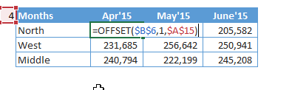

2.5 Now create a **2-D column** chart on the below dataset

2.6 Insert the **2-D Column** chart

2.7 The **2-D Column** chart looks like the following:

2.8 As we move the scroll bar, the months change and the scrollbar chart is created

